

**Monroe County Local 828**

**Proudly Announces the 2024**

**GEORGE M. GROWNEY and FLO TRIPI**

**MEMORIAL SCHOLARSHIPS**

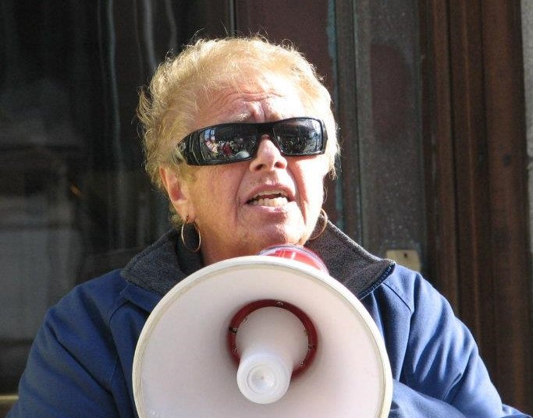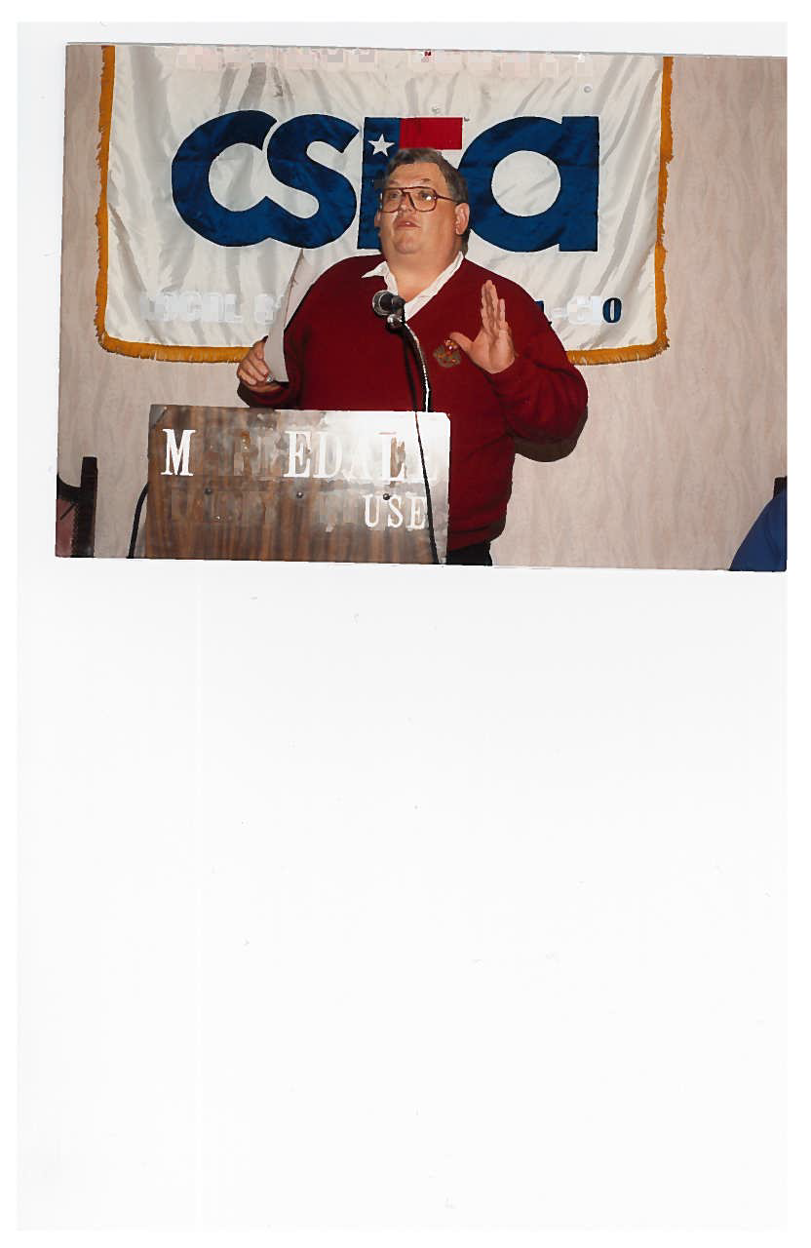

**Children of CSEA Local 828 Members in Good Standing**

**Who will be Graduating from High School in 2024**

**And Entering into College, Vocational, or**

**Apprenticeship Training Programs are encouraged to Apply.**

**Local 828 Will Award**

One (1) $2,500 Scholarship

Two (2) $1,500 Scholarships

Three (3) $1,000 Scholarships

***Applications are Available by Contacting***

*Barbara Fragassi at the CSEA Local 828 Union Office*

*(585) 328-5250 or e-mail CSEA828@rochester.rr.com*

**Winners notified by May 17, 2024**

**Awards Dinner – June 4, 2024, Location – TBD**

 **APPLICATION DEADLINE IS APRIL 19, 2024**